Academic Research Agent Design Report
Table of Contents
Introduction 2
Context 2
Approach 2
Planning: Supervisor Architecture 2
Task Decomposition 3
Memory & Multi-agent Communication 3
Resolution 3
Explainability & Grounding 4
Anticipated Challenges 4
Design 5
References 9
Appendix A: Core Design Components & Challenges 10
Design Choices 10
Anticipated Challenges 10
System Requirements 10
Appendix B: Overview Of Agents 11
Appendix C: Tools & Description of agents 12
Description of Specialized Agents 12
Core Tooling 12

Introduction
This report proposes a multi-agent architecture for an academic research agent (Wooldridge, 2009). The agent supports literature discovery and evidence-organisation by finding sources, ranking them, summarizing documents (Lewis, et al., 2020), extracting claims and hypotheses, checking credibility, identifying subtopics or contradictions (Hearst, 1992), and producing an analysis with supporting citations (Liu, et al., 2023).

Context
Even though academic research is structured, understanding evolves incrementally as more sources are analysed (Bratman, et al., 1988). At the start, the system does not know all relevant subtopics, claims, contradictions, or perspectives; these emerge gradually from sources (Hearst, 1992). Therefore, the architecture must be adaptive: task types stay fixed, while the plan can be refined through subgoals as new information becomes available (Bratman, et al., 1988). The architecture reapplies the same research tasks when new topics, evidence or contradictions are found until resolution (Salemi, et al., 2025).

Approach
The proposed architecture combines a Supervisor architecture for planning, a sequential research pipeline using A2A protocol and a Blackboard Knowledge Hub pattern for multiagent communication, and ConvergenceAgent for resolution (Arsanjani & Bustos, 2026).

Planning: Supervisor Architecture
- A supervisor architecture is used instead of a decentralized architecture since research is structured (Page, et al., 2021). Decentralized architectures are more adaptable, but less predictable, making the process more difficult to explain and audit (Arsanjani & Bustos, 2026). Here, agents do not need to create new tasks at runtime, but the plan adapts in a controlled manner which improves explainability (Arsanjani & Bustos, 2026).
- The SupervisorAgent acts as a request handler. It uses LLM reasoning to understand the user request, define scope, identify initial topics or subtopics, create the initial research plan and call the research agent team to execute it (Yao, et al., 2023).
- If the ConvergenceAgent finds an unexplored subtopic, it submits a request to the SupervisorAgent, so it can create a new subplan for that topic (Bratman, et al., 1988). This keeps the architecture centrally controlled while allowing the plan to adapt incrementally (Arsanjani & Bustos, 2026).

Task Decomposition
- We have chosen to use a static task registry. Academic literature review has a structured set of recurring tasks: identifying sources, screening or filtering studies, appraising evidence, extracting data, synthesising findings, and reporting results (Page, et al., 2021).
- For this use case, the system does not need agents to dynamically create new task types. This would make the system harder to control and audit. Instead, agents work with predefined capabilities. This improves reliability, safety and explainability because every action belongs to a controlled task (Nassim, 2022). The disadvantage is the rigidity of the schema, but because we are unlikely to frequently add tasks to the research process, the reliability and safety advantage of the schema are preferred over the flexibility of other designs (Arsanjani & Bustos, 2026).

Memory & Multi-agent Communication
- The agents communicate through A2A-style messages and the Blackboard Knowledge Hub as a shared memory, since A2A is designed for direct communication between agents in the pipeline (A2A Project, 2025). The Blackboard Knowledge Hub is used as the shared state for the current research request, following the blackboard model of shared problem-solving state (Nii, 1986). The long-term memory is a local vector database, following retrieval-augmented generation’s use of a dense vector index as external memory (Lewis, et al., 2020).
- The Blackboard Knowledge Hub is used as short-term memory for the current request. All agents post outputs to this shared state, such as sources, summaries, extracted claims, hypotheses, credibility scores, contradictions, subtopics, open questions and draft conclusions. The blackboard is therefore not just storage, but also a way for the agents to share information (Nii, 1986). It is the mechanism that allows the research process to evolve while the task registry stays static (Arsanjani & Bustos, 2026).
- This makes the system resilient and auditable. If an agent fails, or the request is interrupted, the system can continue from the latest blackboard state instead of starting from zero. It also makes LLM-based decisions easier to explain, because each decision can be traced back to the source, summary, credibility score, extracted claim or contradiction that triggered it (Arsanjani & Bustos, 2026).

Resolution
- The Controller does not decide every action based on the postings. The pipeline handles the research process through sequential processing. The Controller listens to blackboard postings and acts at loop boundaries, consistent with blackboard architectures where control uses shared problem-solving state (Hayes-Roth, 1985). After a source is processed, it decides whether to call the ConvergenceAgent.
- The ConvergenceAgent checks whether research is sufficient, reflecting resource-bounded reasoning rather than exhaustive certainty (Bratman, et al., 1988). It looks for unprocessed files, unexplored subtopics, weakly supported claims, unresolved contradictions and missing perspectives. If more work is needed, it submits a research request to the SupervisorAgent until there is a state of resolution or no more sources are available. When there is a state of resolution, it allows the PublisherAgent to create the final analysis.
- Although it follows a consensus pattern, the objective to achieve convergence because in academic research sources may disagree. The goal is to decide whether the evidence base is sufficient, transparent, and well-supported enough to publish an analysis (Doshi-Velez & Kim, 2017).

Explainability & Grounding
Explainability is handled by various agents and the blackboard pattern that holds a registry of all facts. The literature has identified the following elements as key for grounding LLMs (Arsanjani & Bustos, 2026)
- In-text citations and links: The ParsingAgent will use chunking strategy that allows cross-referencing and in-text citation. For instance, in the metadata it will store for each paragraph from which page number, document, author, journal, and other relevant information.
- Fact verification and cross-referencing: The ContradictionAgent will cross reference all facts.
- Confidence scores: The CredibilityAgent will ensure that only reliable and reputable sources are being used.
- Request clarification: The supervisor agent will review the ambiguity of the research request. This allows the final report to show why a conclusion was reached, where the information came from and the reliability of the source.

Anticipated Challenges
- Credibility: The academic journals may return outdated sources
- Hallucinations: The LLMs may incorrectly infer claims that are not present in the source
- Resolution: it is difficult to find adequate guardrails that determine when the research is sufficient
- Noisy online data: Extracting evidence from journals, newspapers and other sources that all have their formats will present significant parsing challenges
- Cost: Models with large context windows are better suited for parsing documents but carry greater costs because of the compute requirements. The same for using OCR and other advanced technologies to parse documents.
- Accessibility: Not all content is available through API’s or freely available. It is unlikely that any institution has access to all relevant sources or that all relevant sources have been digitized.

Design
Visualisation 1.1: Flow Diagram View
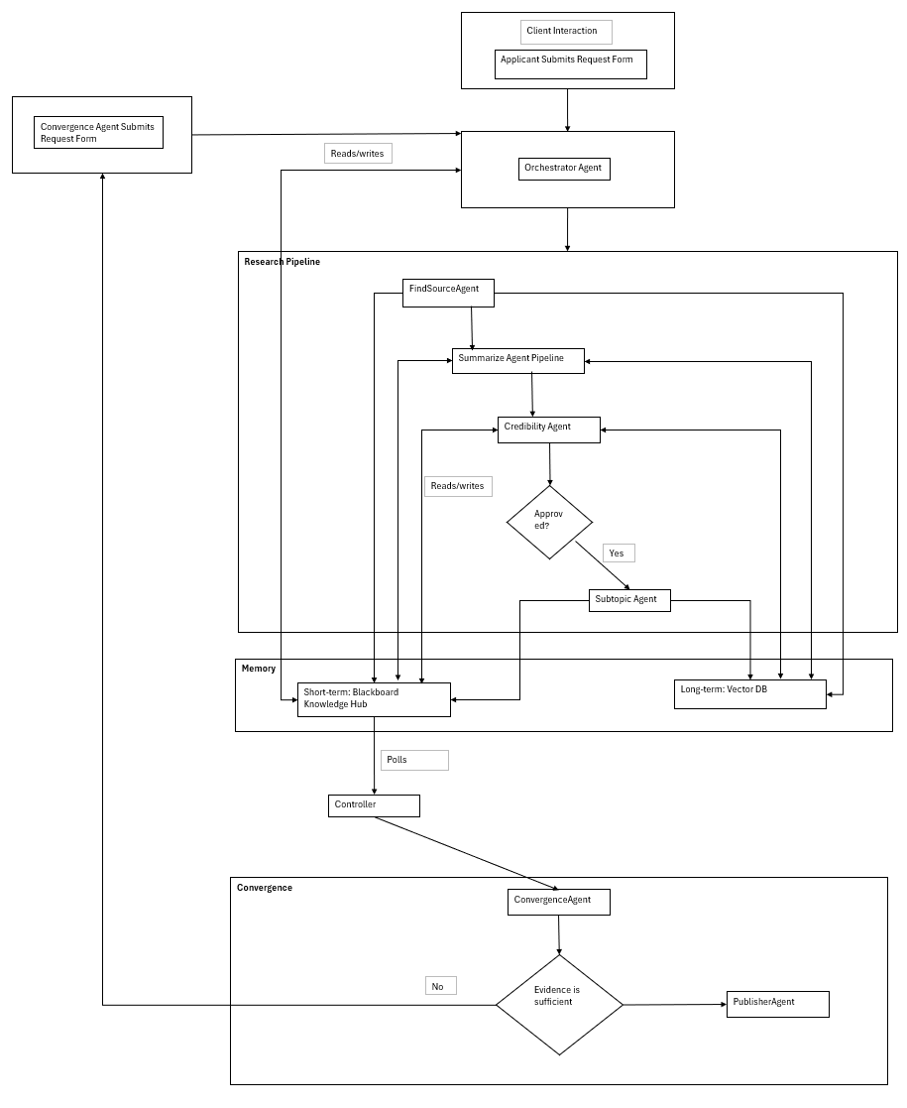

Visualisation 1.2: Flow Diagram View of Summarize Agent Pipeline
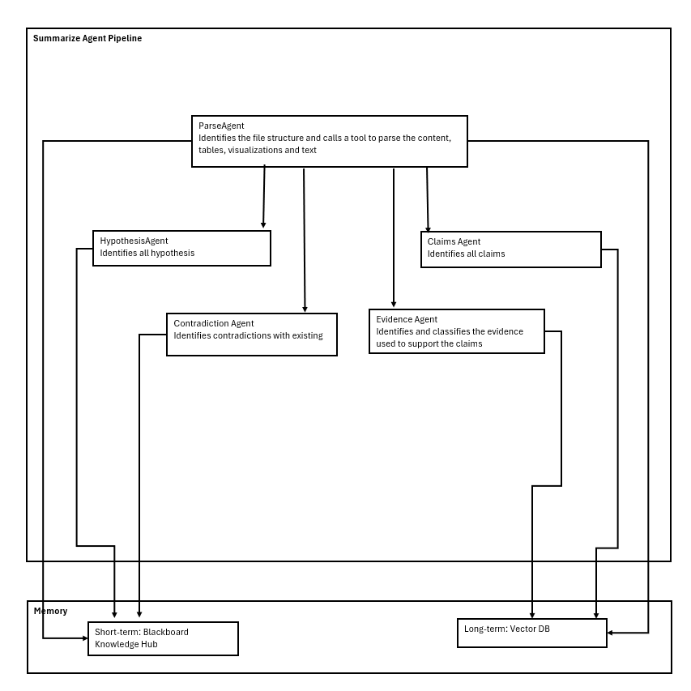
Visualisation 1.3: UML Sequence Diagram View 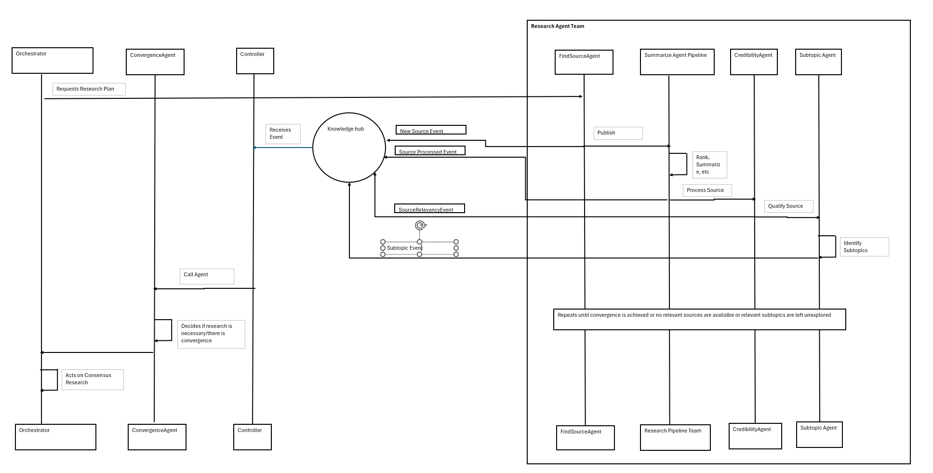
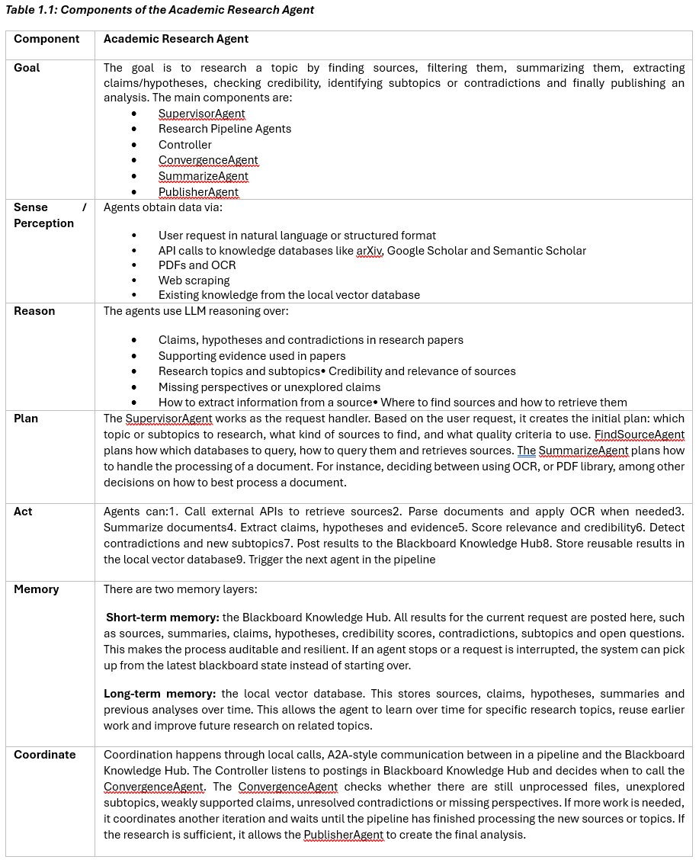
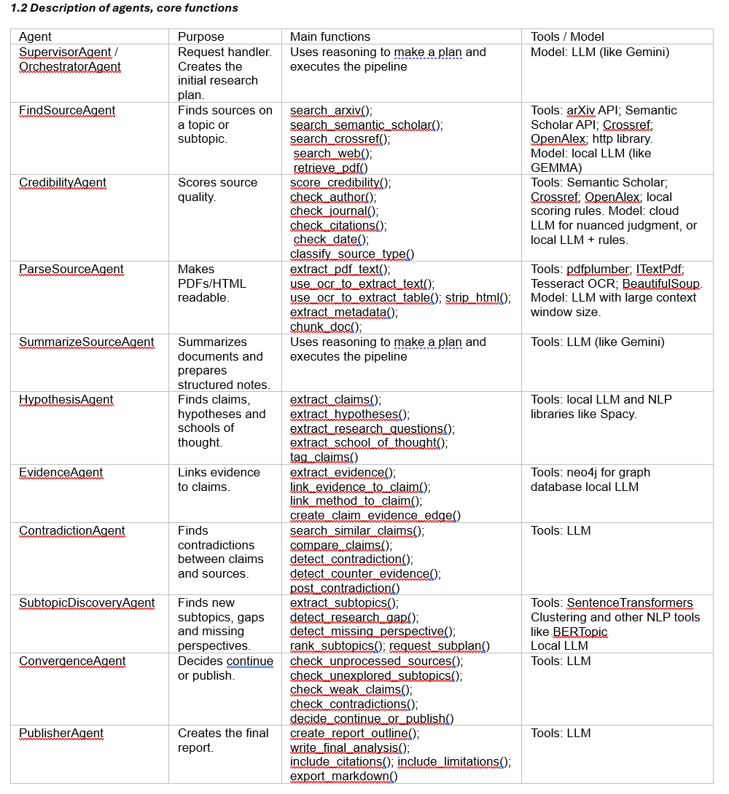

References
- A2A Project, 2025. Agent2Agent Protocol Documentation. [Online]
Available at: https://a2a-protocol.org/latest/
[Accessed 3 June 2026].
- Arsanjani, A. & Bustos, J. P., 2026. Agentic Architectural Patterns for Building Multi-Agent Systems: Proven design patterns and practices for GenAI, agents, RAG, LLMOps, and enterprise-scale AI systems. 1st edn ed. Birmingham: Packt Publishing.
- Bratman, M. E., Israel, D. J. & Pollack, M. E., 1988. Plans and resource-bounded practical reasoning. Computational Intelligence, 4(3), pp. 349-355.
- Doshi-Velez, F. & Kim, B., 2017. Towards A Rigorous Science of Interpretable Machine Learning. arXiv; Machine Learning.
- Hayes-Roth, B., 1985. A blackboard architecture for control. Artificial Intelligence, 26(3), pp. 251-321.
- Hearst, M. A., 1992. Automatic acquisition of hyponyms from large text corpora. COLING 1992 Volume 2: The 14th International Conference on Computational Linguistics.
- Lewis, P. et al., 2020. Retrieval-Augmented Generation for Knowledge-Intensive NLP Tasks. Proceedings of the 34th International Conference on Neural Information Processing Systems, pp. 9459-9474.
- Liu, N., Zhang, T. & Liang, P., 2023. Evaluating Verifiability in Generative Search Engines. Association for Computational Linguistics, pp. 7001-7025.
- Nassim, S. F., 2022. Artificial Intelligence Incidents & Ethics A Narrative Review. International Journal of Technology, Innovation and Management, 2(2), pp. 52-64.
- Nii, H. P., 1986. The blackboard model of problem solving and the evolution of blackboard architectures. AI Magazine, 7(2), pp. 38-53.
- Page, M. J. et al., 2021. The PRISMA 2020 statement: an updated guideline for reporting systematic reviews. BMJ, Volume 372.
- Salemi, A. et al., 2025. LLM-based Multi-Agent Blackboard System for Information Discovery in Data Science. ArXiv.
- Wooldridge, M., 2009. An Introduction to MultiAgent Systems. 2nd ed. s.l.:John Wiley & Sons.
- Yao, S. et al., 2023. ReAct: Synergizing Reasoning and Acting in Language Models. Kigali, Rwanda, 11th International Conference on Learning Representations.

Appendix A: Core Design Components & Challenges

Design Choices
- Supervisor architecture
- Blackboard knowledge hub
- Static task registry
- A2A protocol
- Grounding
- Convergence/Consensus pattern

Anticipated Challenges
- Credibility: The academic journals may return outdated sources
- Hallucinations: The LLMs may incorrectly infer claims that are not present in the source
- Resolution: it is difficult to find adequate guardrails that determine when the research is sufficient
- Noisy online data: Extracting evidence from journals, newspapers and other sources that all have their formats will present significant parsing challenges
- Cost: Models with large context windows are better suited for parsing documents but carry greater costs because of the compute requirements. The same for using OCR and other advanced technologies to parse documents.
- Accessibility: Not all content is available through API’s or freely available. It is unlikely that any institution has access to all relevant sources or that all relevant sources have been digitized.

System Requirements
- Access to academic APIs, such as, arXiv, Semantic scholar and other platforms
- System assumes that the goal in academic research is convergence rather than consensus.
- The agent must support end-to-end academic research process from finding to processing and analysing sources.

Appendix B: Overview Of Agents

Table 1.1: Components of the Academic Research Agent
Component | Academic Research Agent
Goal | The goal is to research a topic by finding sources, filtering them, summarizing them, extracting claims/hypotheses, checking credibility, identifying subtopics or contradictions and finally publishing an analysis. The main components are:  - SupervisorAgent  - Research Pipeline Agents  - Controller  - ConvergenceAgent  - SummarizeAgent  - PublisherAgent
Sense / Perception | Agents obtain data via:  - User request in natural language or structured format  - API calls to knowledge databases like arXiv, Google Scholar and Semantic Scholar  - PDFs and OCR  - Web scraping  - Existing knowledge from the local vector database
Reason | The agents use LLM reasoning over:  - Claims, hypotheses and contradictions in research papers  - Supporting evidence used in papers  - Research topics and subtopics• Credibility and relevance of sources  - Missing perspectives or unexplored claims  - How to extract information from a source• Where to find sources and how to retrieve them
Plan | The SupervisorAgent works as the request handler. Based on the user request, it creates the initial plan: which topic or subtopics to research, what kind of sources to find, and what quality criteria to use. FindSourceAgent plans how which databases to query, how to query them and retrieves sources. The SummarizeAgent plans how to handle the processing of a document. For instance, deciding between using OCR, or PDF library, among other decisions on how to best process a document.
Act | Agents can:1. Call external APIs to retrieve sources2. Parse documents and apply OCR when needed3. Summarize documents4. Extract claims, hypotheses and evidence5. Score relevance and credibility6. Detect contradictions and new subtopics7. Post results to the Blackboard Knowledge Hub8. Store reusable results in the local vector database9. Trigger the next agent in the pipeline
Memory | There are two memory layers:  Short-term memory: the Blackboard Knowledge Hub. All results for the current request are posted here, such as sources, summaries, claims, hypotheses, credibility scores, contradictions, subtopics and open questions. This makes the process auditable and resilient. If an agent stops or a request is interrupted, the system can pick up from the latest blackboard state instead of starting over.  Long-term memory: the local vector database. This stores sources, claims, hypotheses, summaries and previous analyses over time. This allows the agent to learn over time for specific research topics, reuse earlier work and improve future research on related topics.
Coordinate | Coordination happens through local calls, A2A-style communication between in a pipeline and the Blackboard Knowledge Hub. The Controller listens to postings in Blackboard Knowledge Hub and decides when to call the ConvergenceAgent. The ConvergenceAgent checks whether there are still unprocessed files, unexplored subtopics, weakly supported claims, unresolved contradictions or missing perspectives. If more work is needed, it coordinates another iteration and waits until the pipeline has finished processing the new sources or topics. If the research is sufficient, it allows the PublisherAgent to create the final analysis.

Appendix C: Tools & Description of agents

Description of Specialized Agents
1.2 Description of agents, core functions
Agent | Purpose | Main functions | Tools / Model
SupervisorAgent / OrchestratorAgent | Request handler. Creates the initial research plan. | Uses reasoning to make a plan and executes the pipeline | Model: LLM (like Gemini)
FindSourceAgent | Finds sources on a topic or subtopic. | search_arxiv(); search_semantic_scholar(); search_crossref();  search_web();  retrieve_pdf() | Tools: arXiv API; Semantic Scholar API; Crossref; OpenAlex; http library.  Model: local LLM (like GEMMA)
CredibilityAgent | Scores source quality. | score_credibility();  check_author();  check_journal();  check_citations();  check_date();  classify_source_type() | Tools: Semantic Scholar; Crossref; OpenAlex; local scoring rules. Model: cloud LLM for nuanced judgment, or local LLM + rules.
ParseSourceAgent | Makes PDFs/HTML readable. | extract_pdf_text(); use_ocr_to_extract_text(); use_ocr_to_extract_table(); strip_html();  extract_metadata();  chunk_doc(); | Tools: pdfplumber; ITextPdf; Tesseract OCR; BeautifulSoup.  Model: LLM with large context window size.
SummarizeSourceAgent | Summarizes documents and prepares structured notes. | Uses reasoning to make a plan and executes the pipeline | Tools: LLM (like Gemini)
HypothesisAgent | Finds claims, hypotheses and schools of thought. | extract_claims();  extract_hypotheses(); extract_research_questions(); extract_school_of_thought(); tag_claims() | Tools: local LLM and NLP libraries like Spacy.
EvidenceAgent | Links evidence to claims. | extract_evidence(); link_evidence_to_claim(); link_method_to_claim(); create_claim_evidence_edge() | Tools: neo4j for graph database local LLM
ContradictionAgent | Finds contradictions between claims and sources. | search_similar_claims(); compare_claims(); detect_contradiction(); detect_counter_evidence(); post_contradiction() | Tools: LLM
SubtopicDiscoveryAgent | Finds new subtopics, gaps and missing perspectives. | extract_subtopics(); detect_research_gap(); detect_missing_perspective(); rank_subtopics(); request_subplan() | Tools: SentenceTransformers  Clustering and other NLP tools like BERTopic  Local LLM
ConvergenceAgent | Decides continue or publish. | check_unprocessed_sources(); check_unexplored_subtopics(); check_weak_claims(); check_contradictions(); decide_continue_or_publish() | Tools: LLM
PublisherAgent | Creates the final report. | create_report_outline(); write_final_analysis(); include_citations(); include_limitations(); export_markdown() | Tools: LLM

Core Tooling
Layer | Free/local choice | Purpose
Blackboard | SQLite/RDMS store | Stores all postings for the current request. Makes the process auditable and allows the system to continue where it stopped.
Vector DB | Chroma/Pinecone | Stores sources, summaries, claims and previous analyses so the agent can reuse knowledge and learn over time.
Embeddings | SentenceTransformers | Creates vectors for similarity search.
PDF parsing | GROBID, PyMuPDF, pdfplumber | Extracts text, metadata, sections and references.
OCR | Tesseract OCR/Azure Document Intelligence | Extracts text and tables from scanned documents.
HTML parsing | BeautifulSoup | Strips HTML tags and makes noisy web data readable.
Academic search | arXiv API, Semantic Scholar API, Crossref, OpenAlex | Finds papers and metadata (free)
Workflow | Langraph | Simple free orchestration

